### Tableau Lecture 3: Data Structuring options

### **Agenda**

* Basic Charts
  + Text Table
  + Highlight Table
  + Heat Map
* Data Structuring
  + Groups
  + Sets
  + Group vs Set
  + Parameters

#### Dataset : [sample superstore](https://docs.google.com/spreadsheets/d/1Kt-ZZqiJ9483tEpOShNYRvmbAgnC0eN5/edit?usp=share_link&ouid=100659516601446935794&rtpof=true&sd=true)

### **Text Table**

* Also known as **CrossTab** or **Pivot Table**.
* They are useful in below cases :
  + When the end user is more comfortable in reading data in tabular form.
  + To export Raw Data - any view in a worksheet can be duplicated as text table.
  + To create a filter action in dashboards.
* Duplicating a view as Text Table
  + Drag Category to Columns
  + Drag Sales to Rows
  + Right Click on the Sheet
  + Choose Duplicate as Crosstab

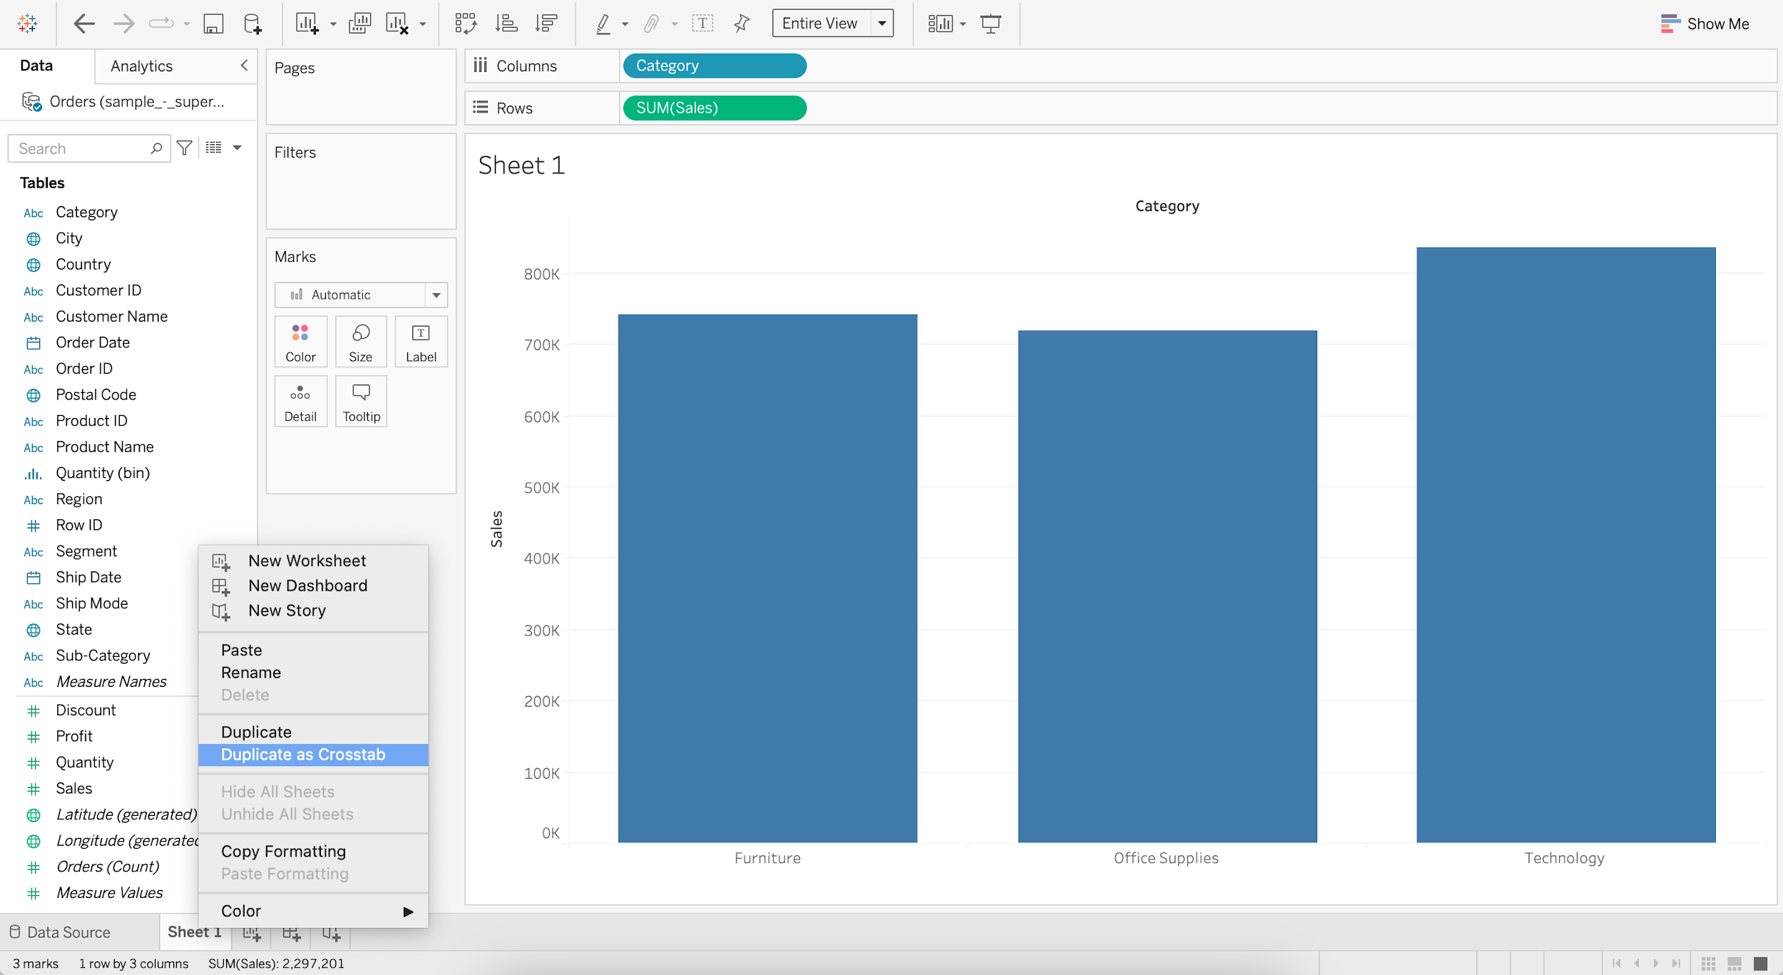  
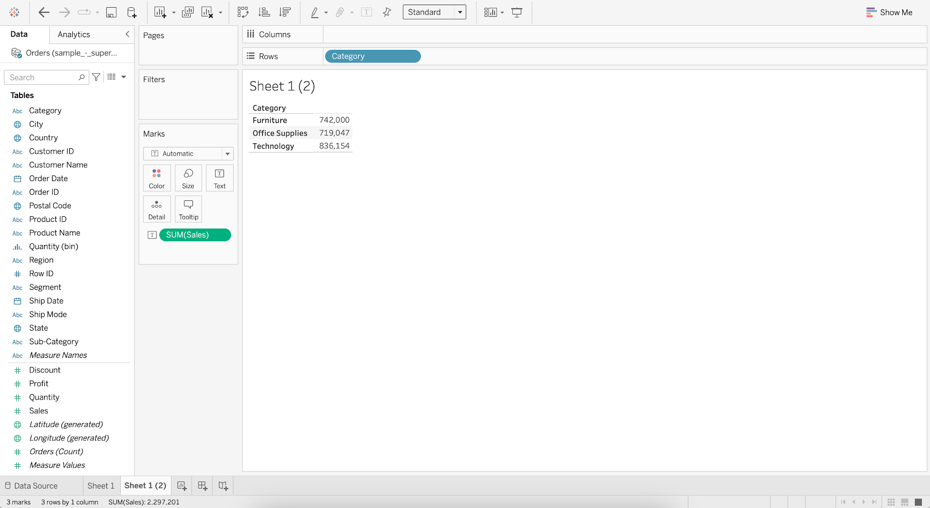

#### **Business problem 1 :**

* Display sales of for each subcategory by region for all the years in a table format.
  + Drag Order Date to Columns
  + Drag Sub-Category to Rows
  + Drag Region to Rows
  + Add Sales to Label
  + Switch to Fit Width

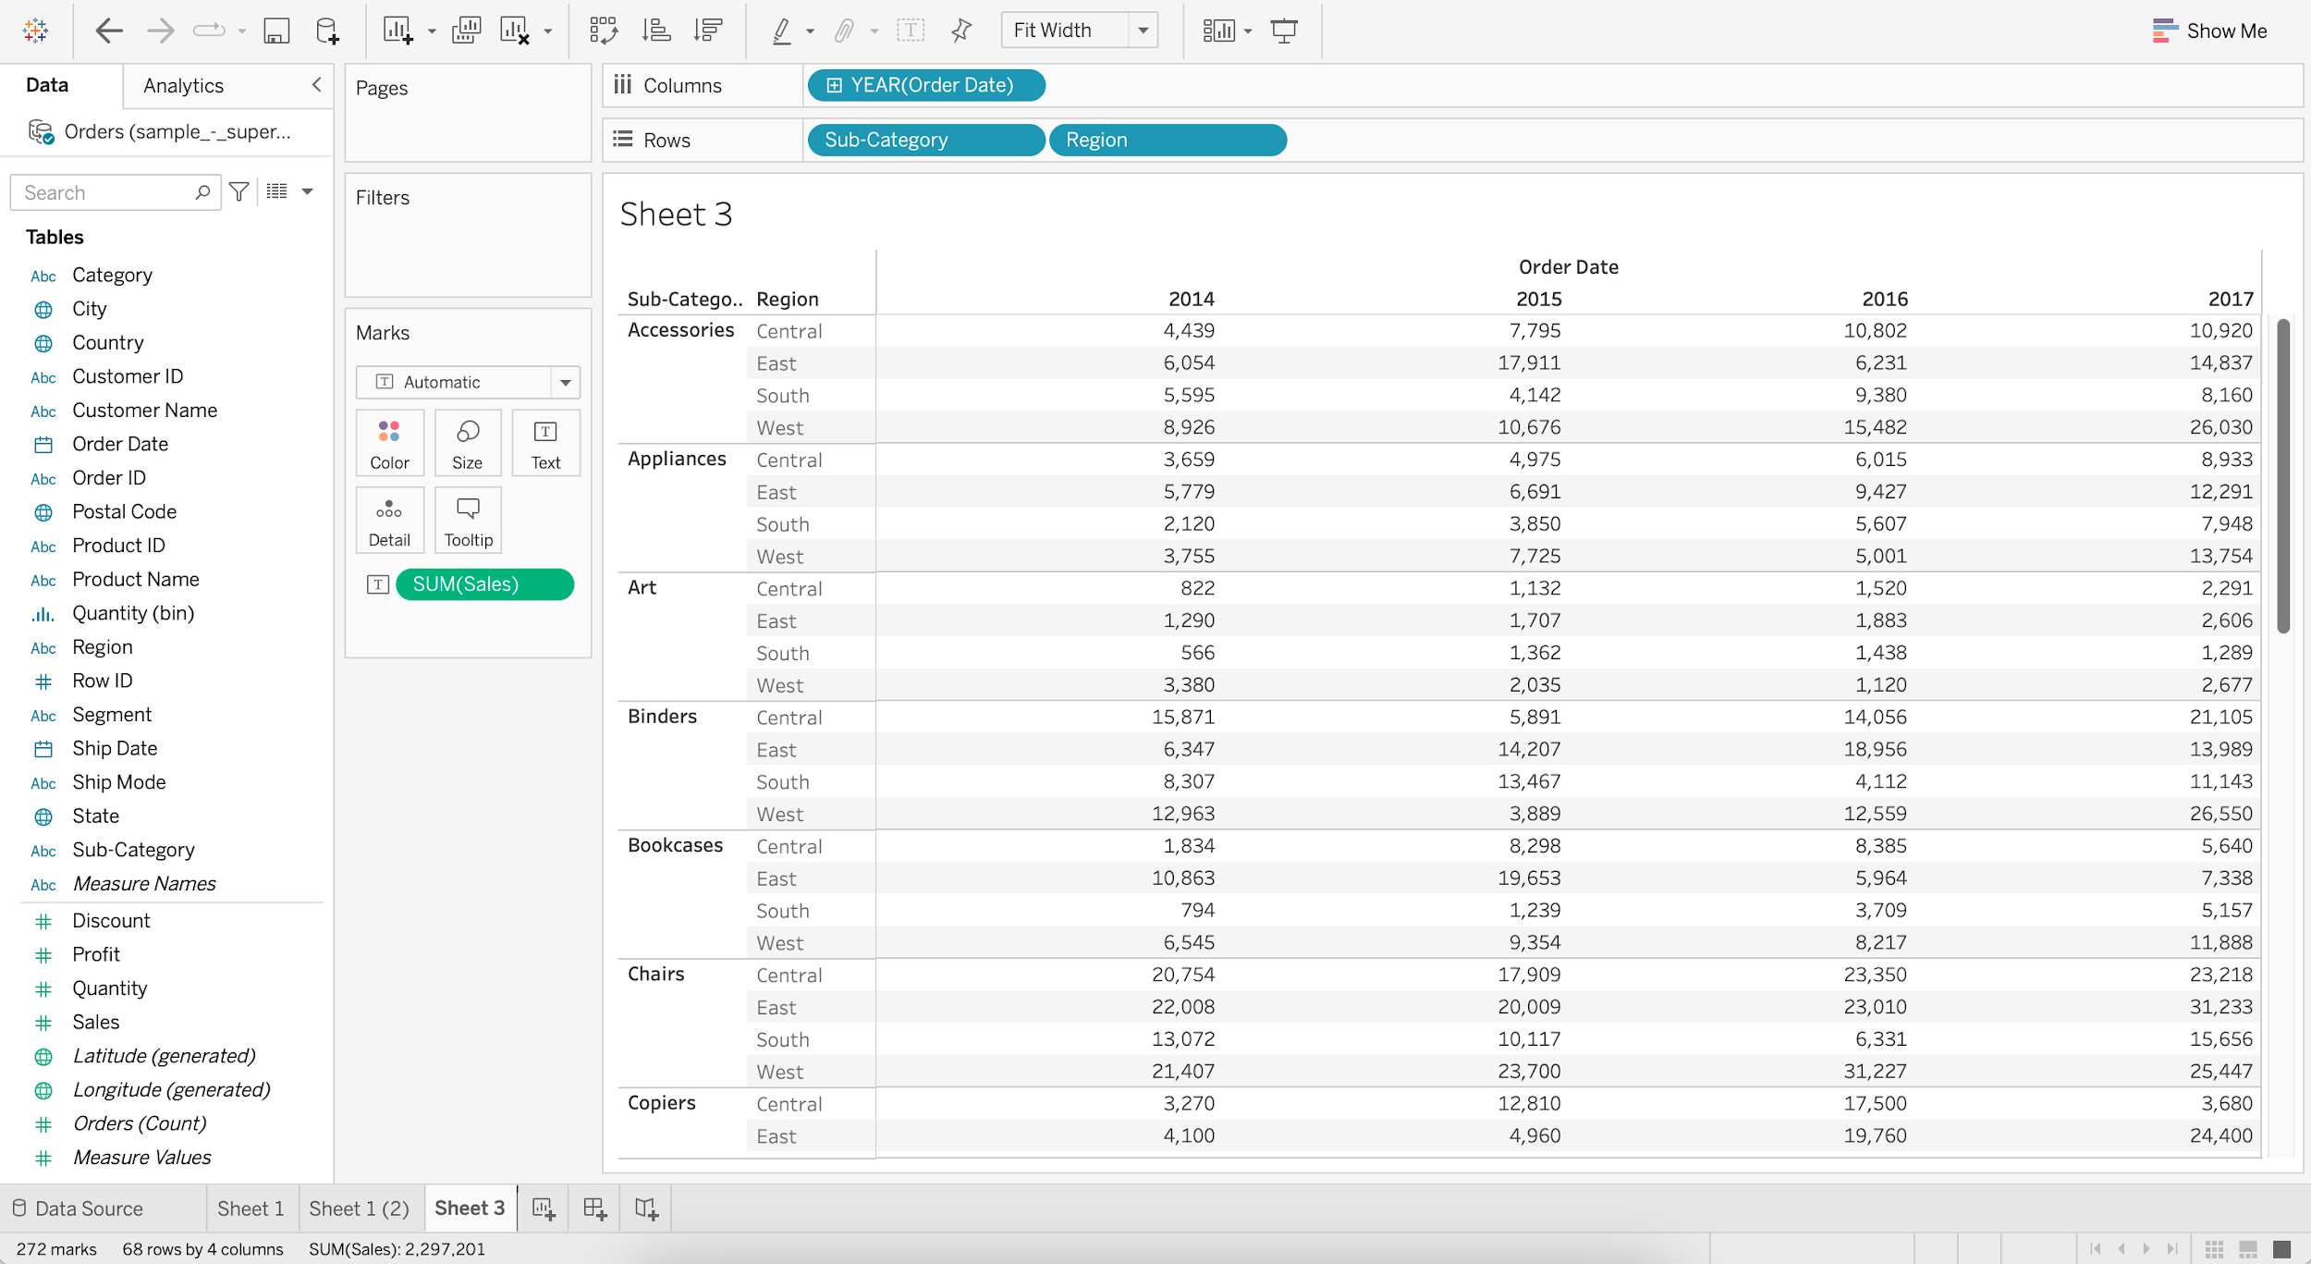

### **Highlight Table**

* It is used to enhance the text table and provide better insights in a glance.
* It requires 1 or more dimension on the Column shelf, 1 or more dimension on the Row shelf and 1 measure in the Color marks shelf.

#### **Business problem 2 :**

* Display sales of for each subcategory by region for all the years in a table format and highlight values that have the highest and lowest sales.
  + Create the Text Table
    - Drag Order Date to Columns
    - Drag Sub-Category to Rows
    - Drag Region to Rows
    - Add Sales to Label
    - Switch to Fit Width

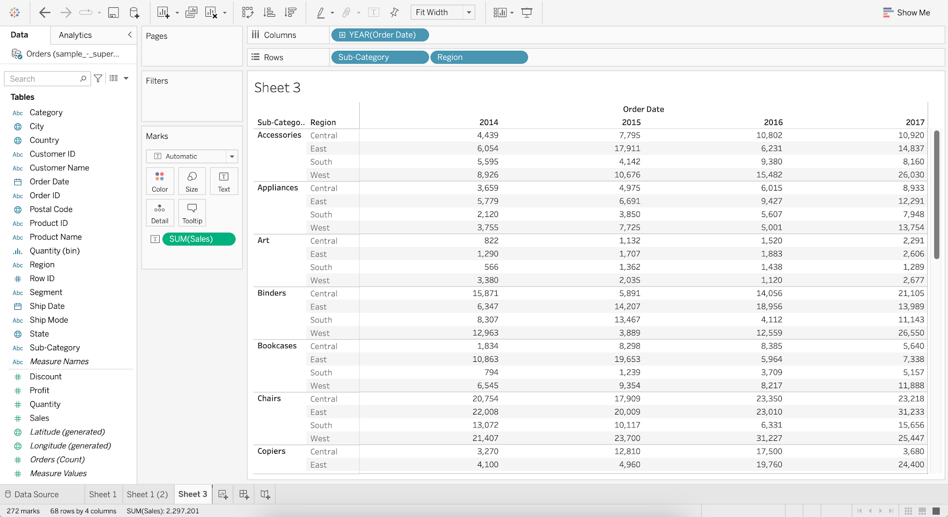

* + Add Sales to Color

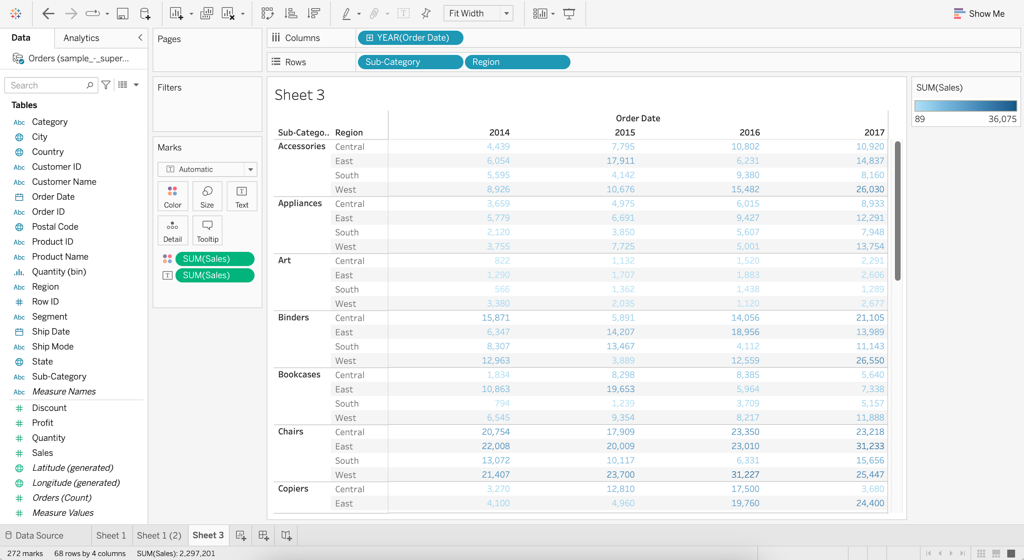

* + Change Marks from Automatic to Square

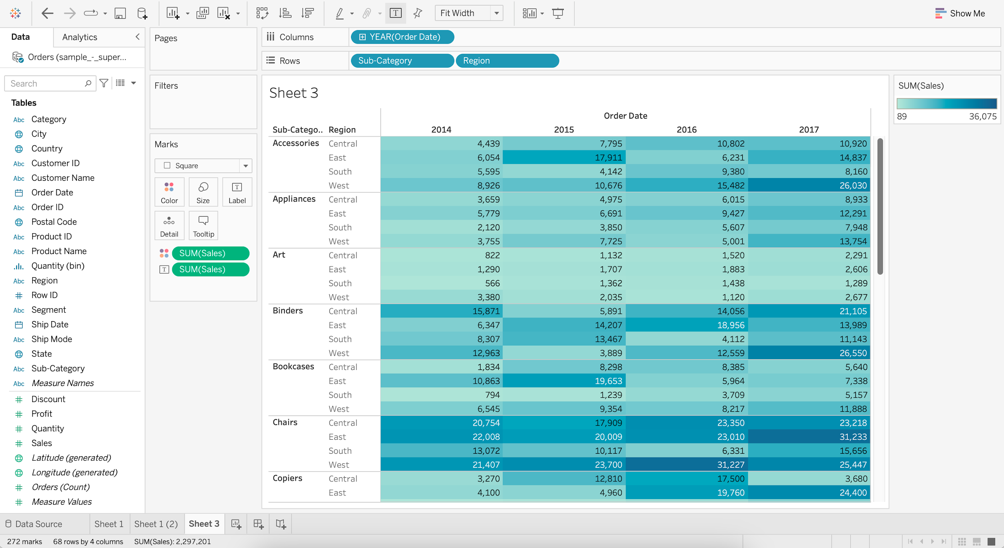

### **Heat Map**

* It requires 1 or more dimensions and 1 or 2 measures.

#### **Difference between Heat Map and Highlight Table**

* In the highlight table our only option is to Color the marks using the measures.
* In the heat map in addition to this we can also Size the marks by 1 measure.

#### **Business problem 3 :**

* Display the sales and profit for each subcategory by region for all the years in a table format.
  + Create the Highlight Table
    - Drag Order Date to Columns
    - Drag Sub-Category to Rows
    - Drag Region to Rows
    - Add Sales to Color

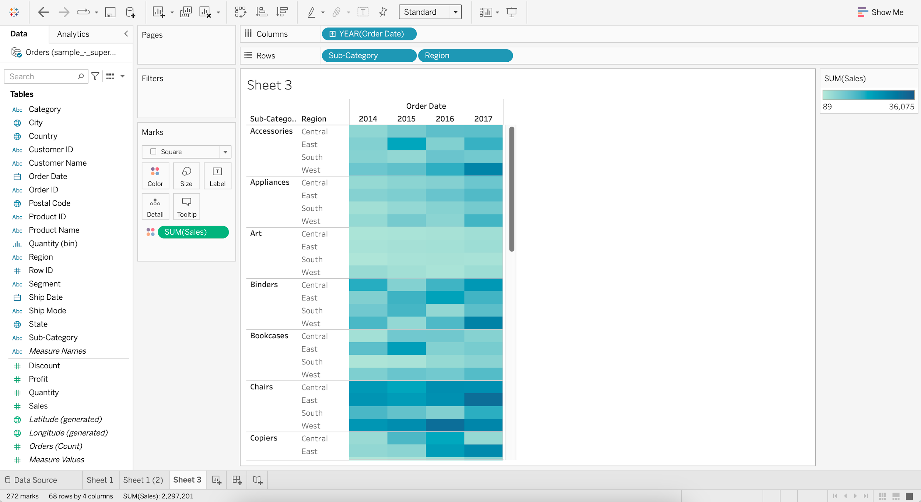

* + Add Profit to Size
  + Increase the Size

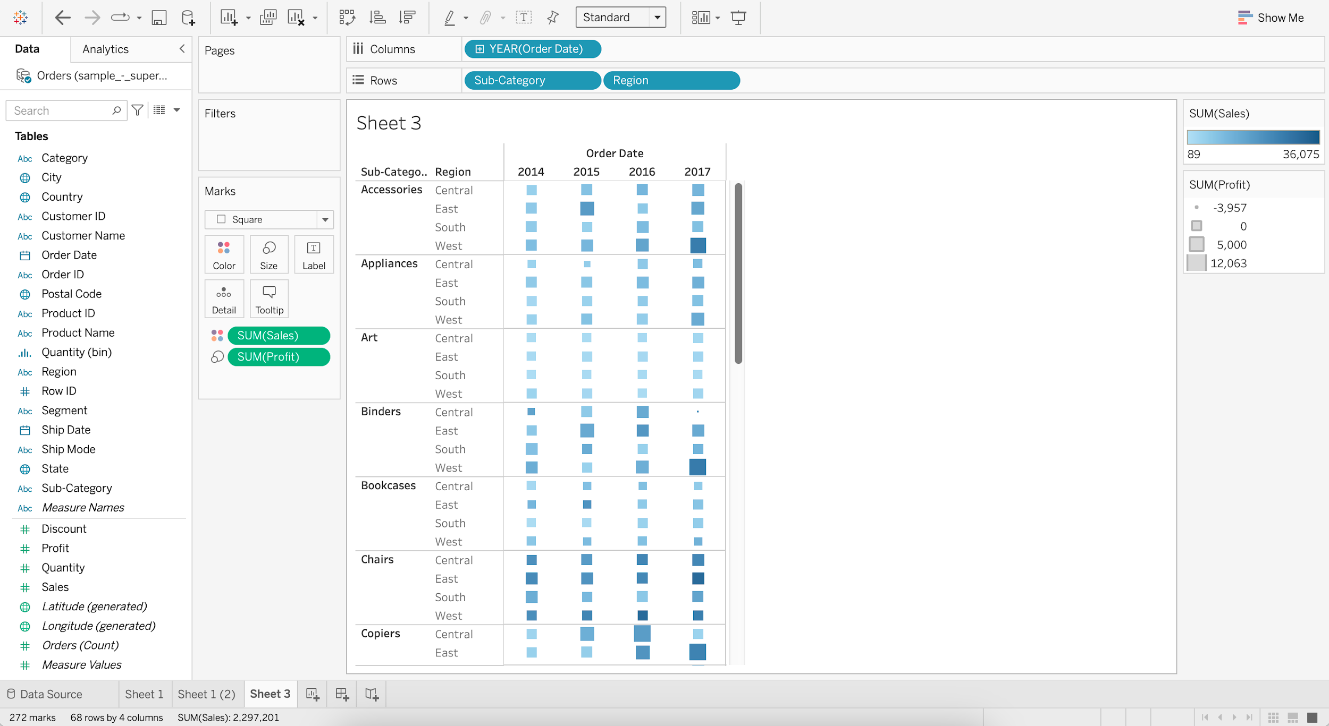

We can easily see that the highest profit for accessories was for the west region in the year 2017.

**Group**

* Tableau allows 1-dimensional members to be grouped together and automatically creates a new dimension with Tableau Group at the end of the name.
* Tableau makes no adjustments to the members’ original dimensions.

#### **Business problem 4 :**

* Create a group called “small items” which includes Binder, Bookcases, Envelope, Fastener, Supplies and compare its sales with the rest of the sub-categories.
  + For Sub-Category, go to Create and choose Group
  + Select Binder, Bookcases, Envelope, Fastener, and Supplies
  + Click on Group
  + Rename the Group as “Small Items”
  + Click OK

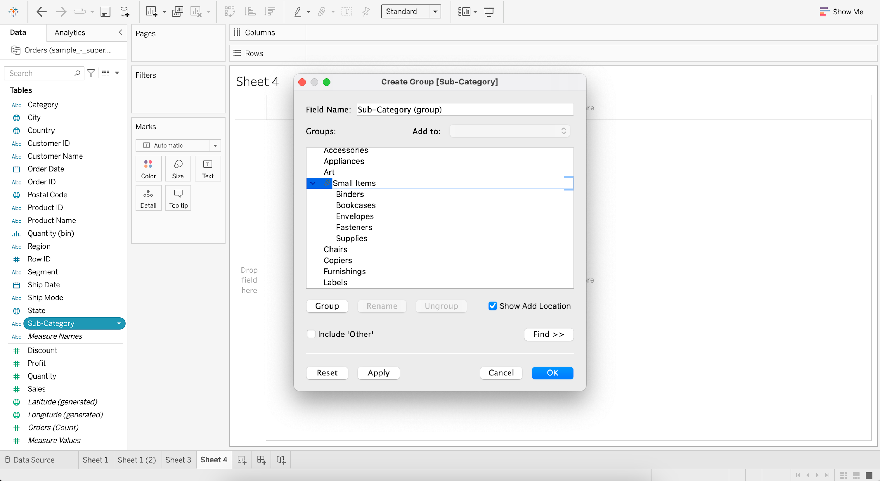

* + Drag Sub-Category (group) to Column
  + Drag Sales to Rows

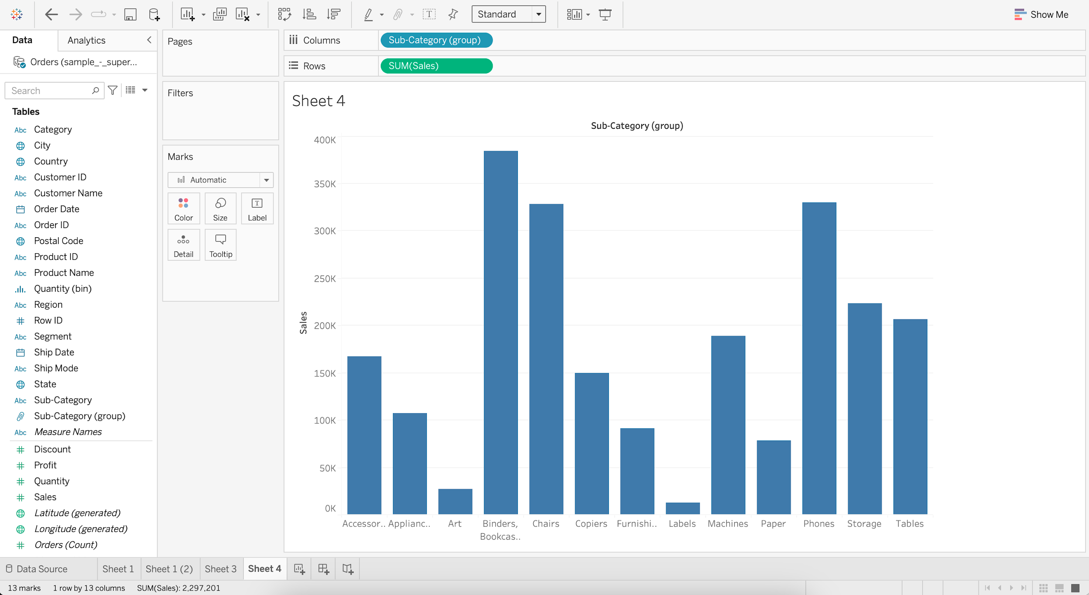

### **Set**

* Sets are custom fields that are used to keep a subset of data based on a condition.
* When you drag a Set to the visualization, Tableau displays the Set using the In/Out mode.
* This is a binary categorization of Sets :
  + In-Members that are inside the Set
  + Out-Members that aren’t part of the Set

#### **Static Set**

* Members of a static set do not change if the underlying data changes.

#### **Business problem 5 :**

* Create a set of customers with the highest profit.
  + Create a table which displays profit by each customer.
    - Drag Customer Name to Rows
    - Add Profit to Label
    - Sort in descending order

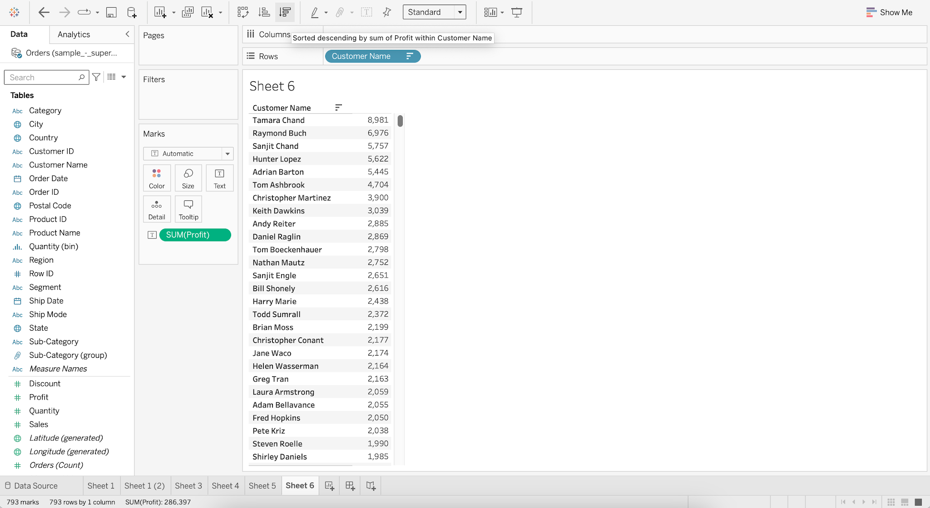

* + Select the first 11 records
  + Click on Create Set

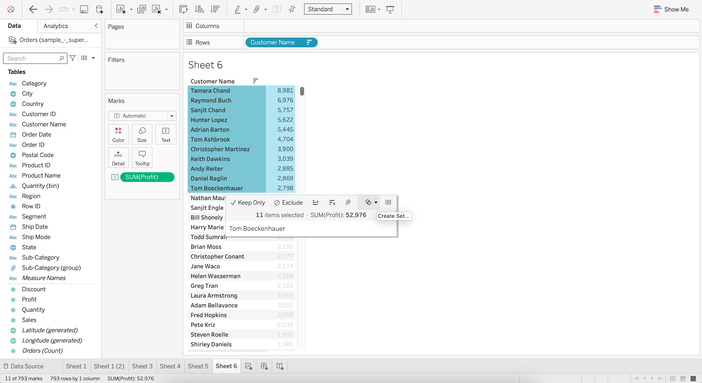

* + Rename the Set as “customers with highest profit”

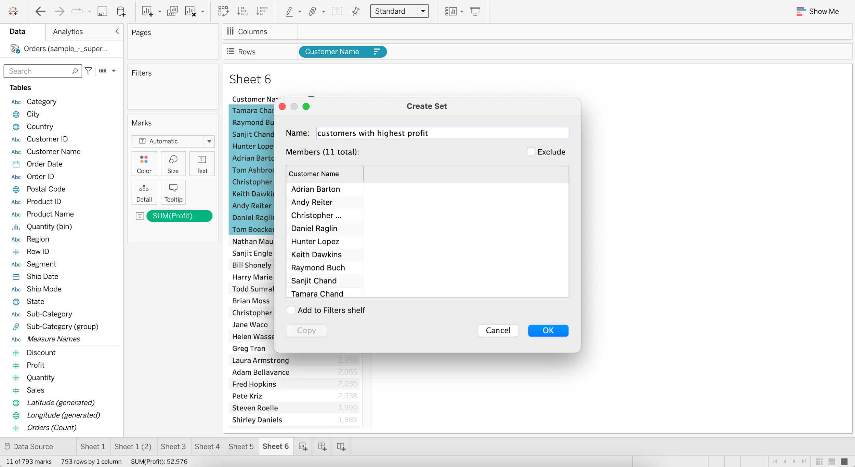

#### **Dynamic Set**

* Members of the dynamic set change when the underlying data changes.

#### **Business problem 6 :**

* Find the top 5 products subcategories by sales.
  + Create a bar chart to visualize sales by each sub-category.
    - Drag Sub-Category to Columns
    - Drag Sales to Rows

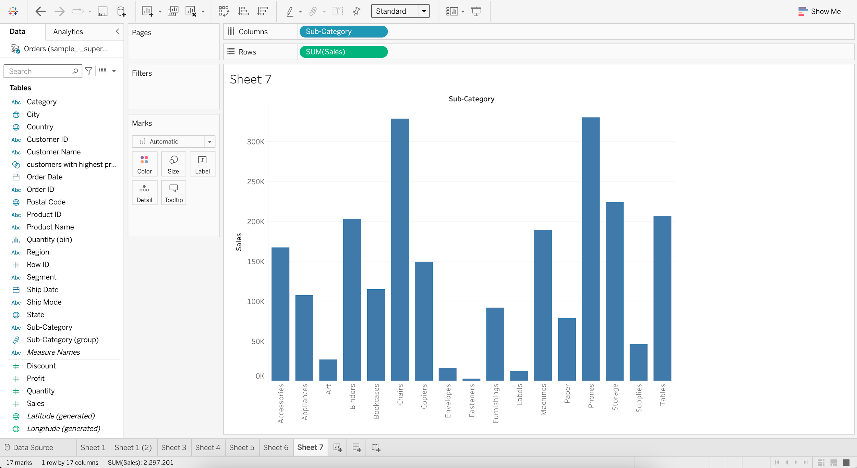

* + - For Sub-Category, go to Create and choose Set

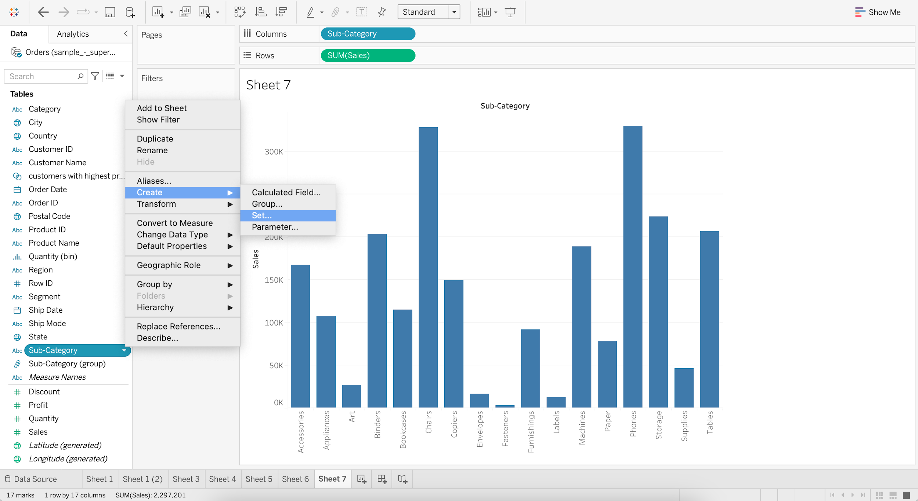

* + - Select ALL from list and click OK

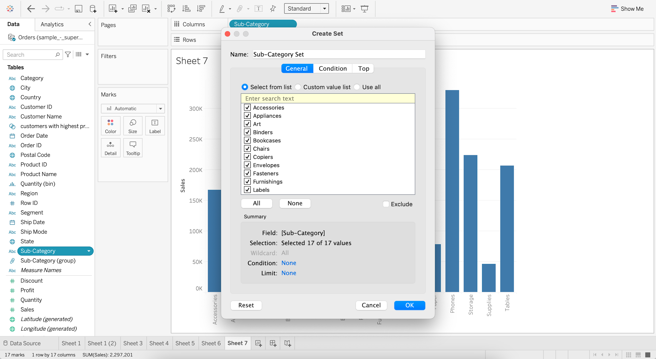

* + - Show Members of Sub-Category Set

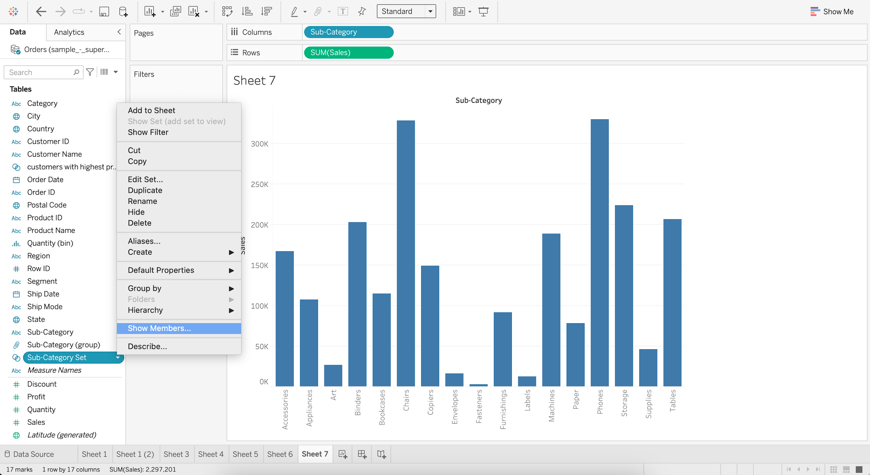  
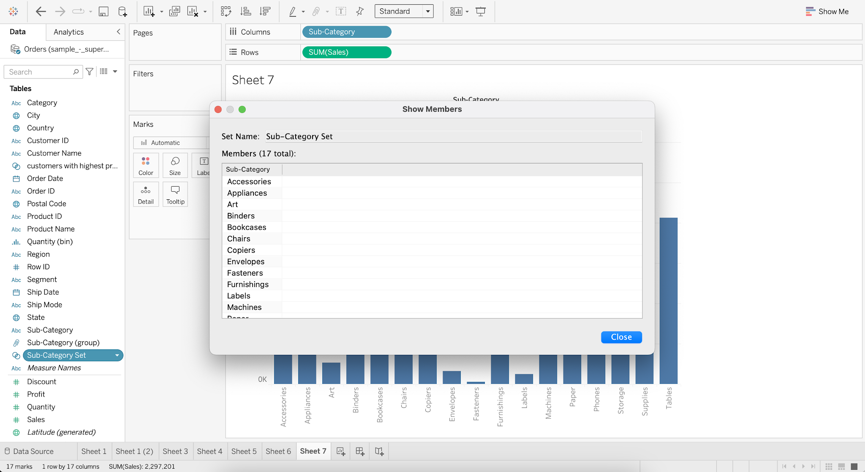

* + - For Sub-Category Set, go to Edit Set
    - Go to Top and Select Top 5 Fields by Sum of Sales

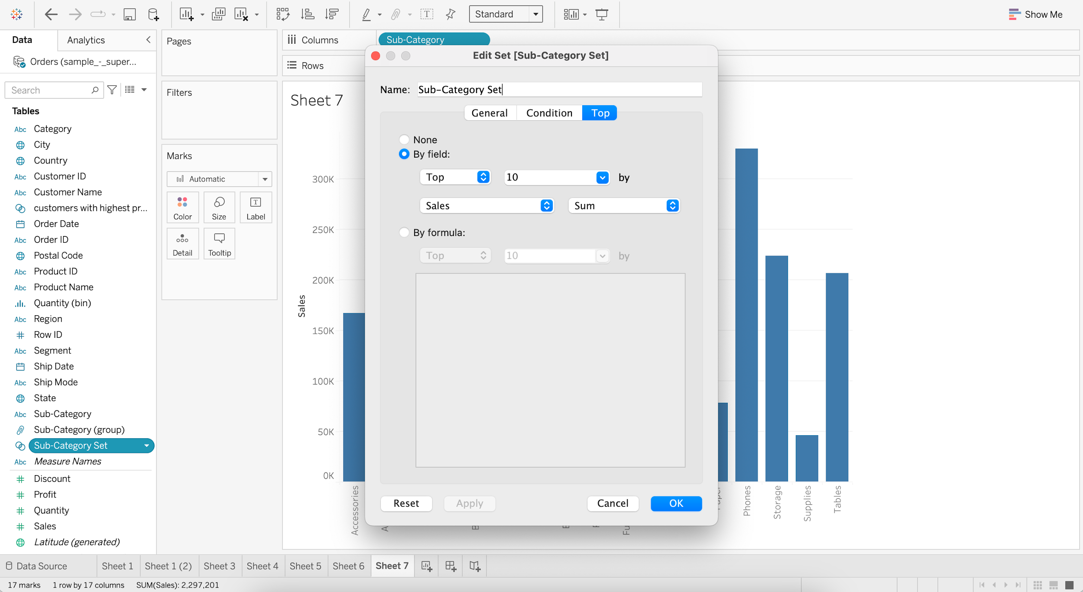

* + - Add Sub_category Set to Color

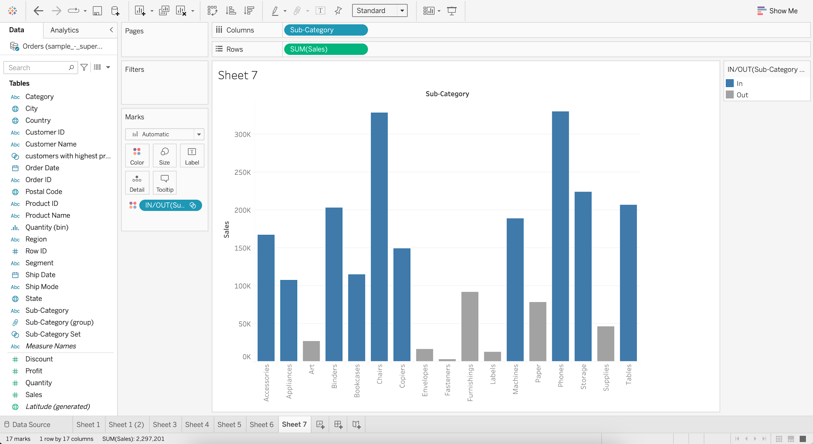

The ones in Blue are within the Set.  
The ones in Grey are outside the Set.

#### **Combined Set**

* Allows us to compare members from 2 different sets.

#### **Business problem 7 :**

* Find the top customers by sales but with low profitability.
  + Create Set 1, which is “Top 20 customers by Sales”

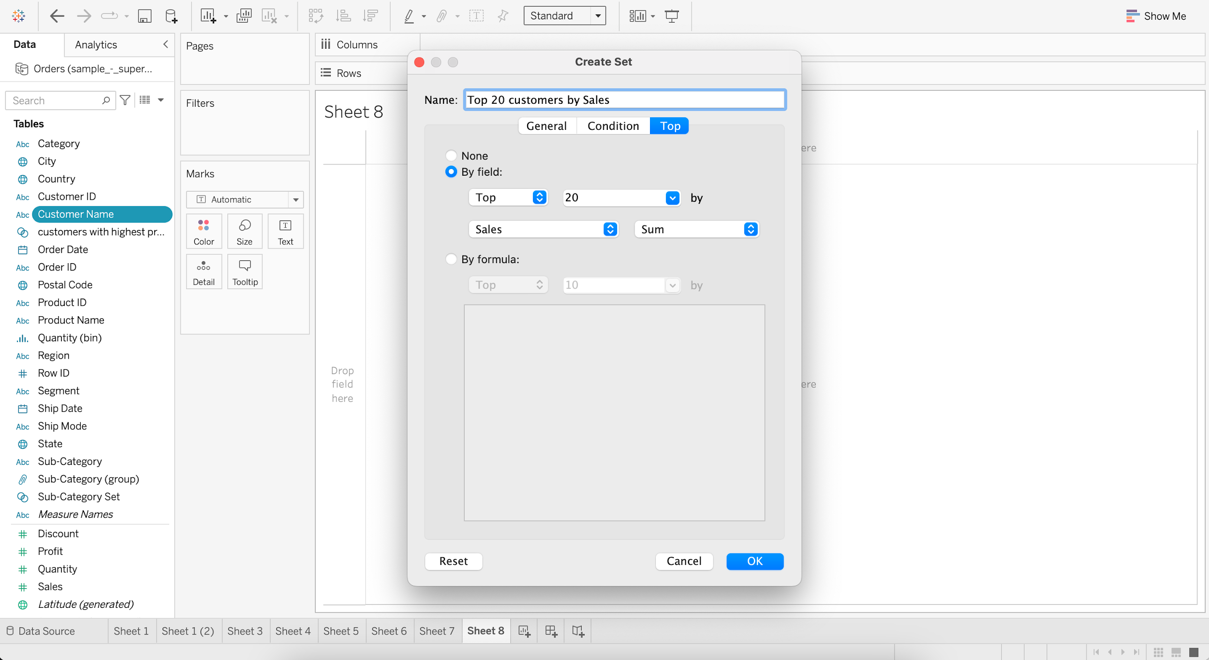

* + Create Set 2, which is “Bottom 20 customers by Profit”

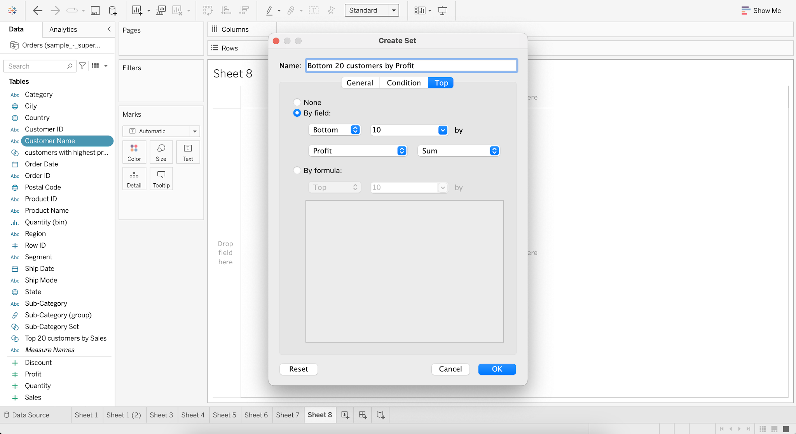

* + Create a Combined Set as “Customers with high Sales and low Profit”

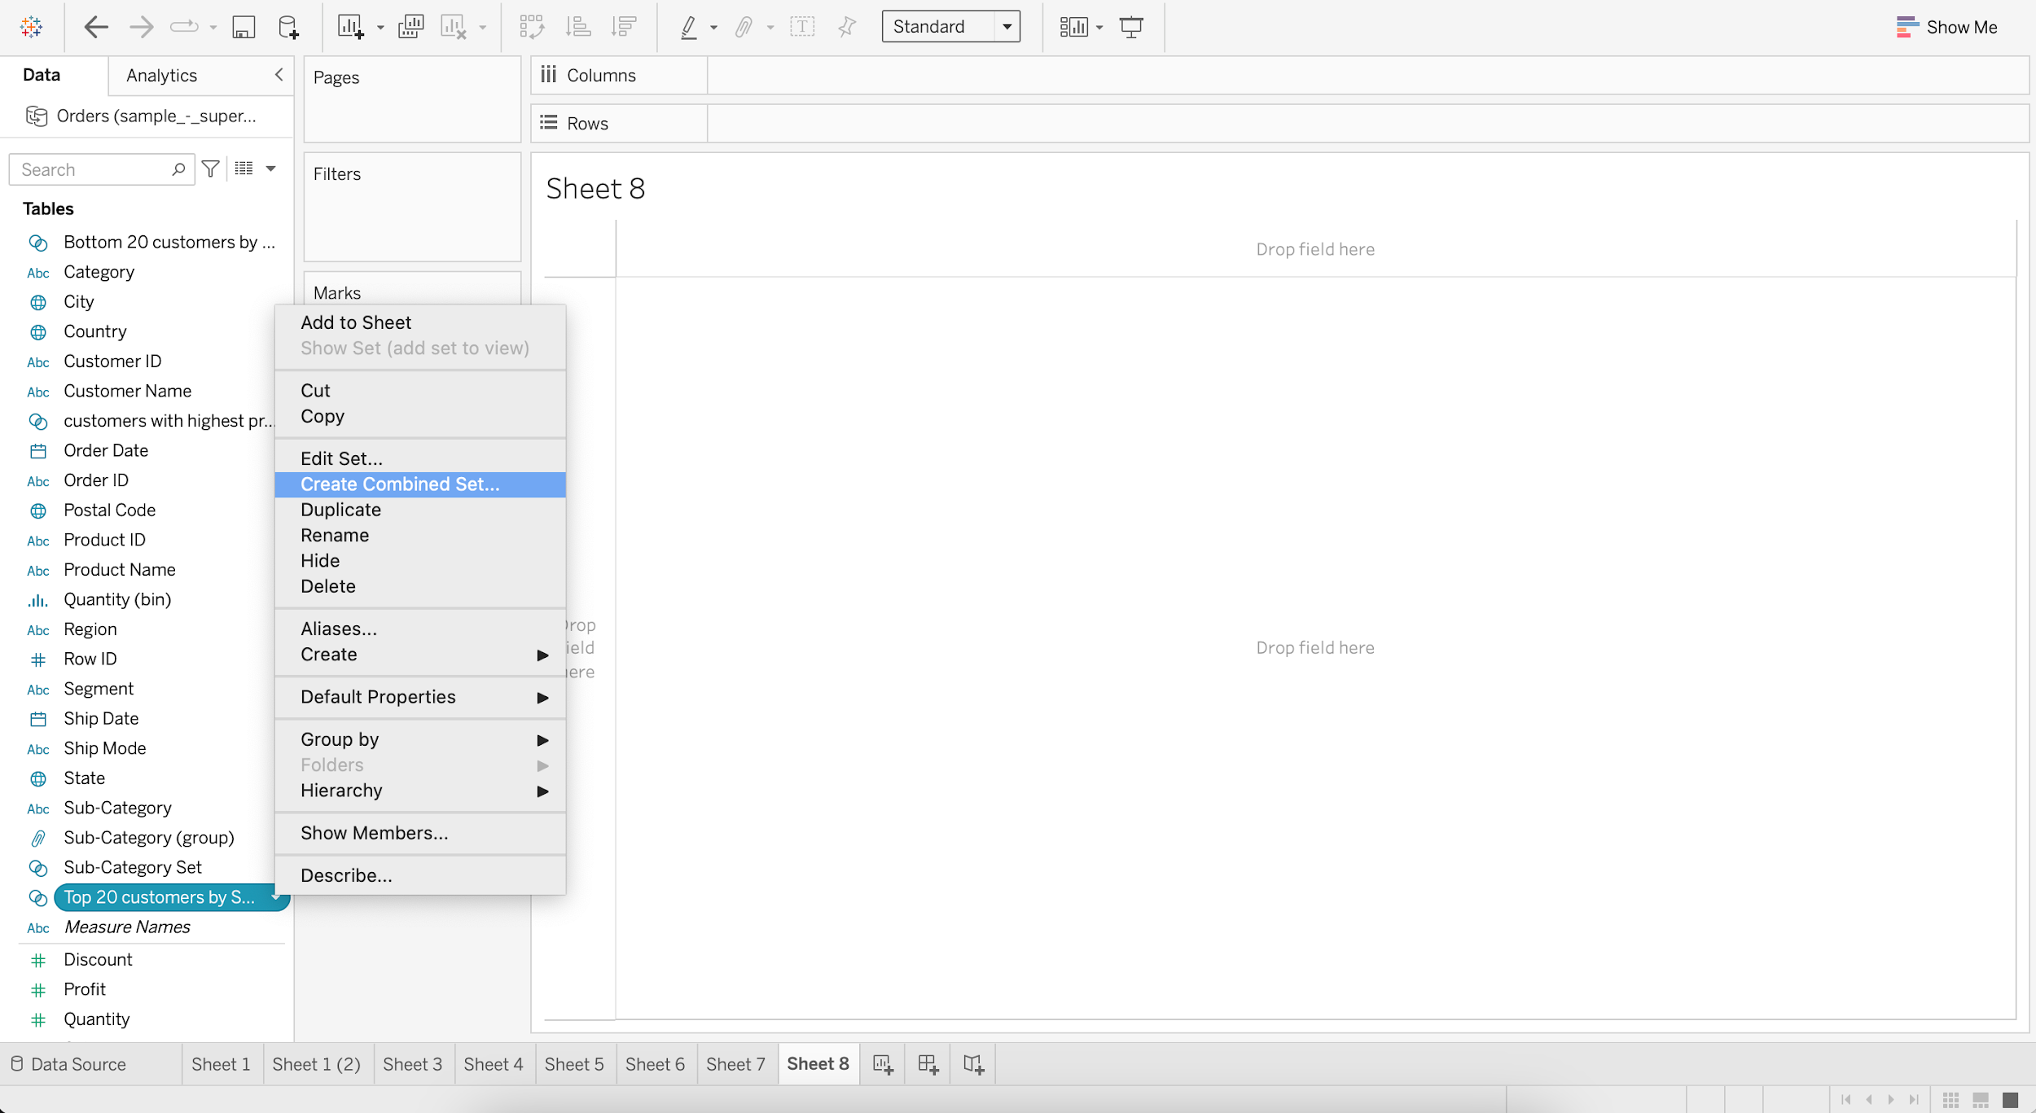

* + Combine sets “Top 20 customers by Sales” and “Bottom 20 customers by Profit”
  + Choose Shared members in both sets and click OK

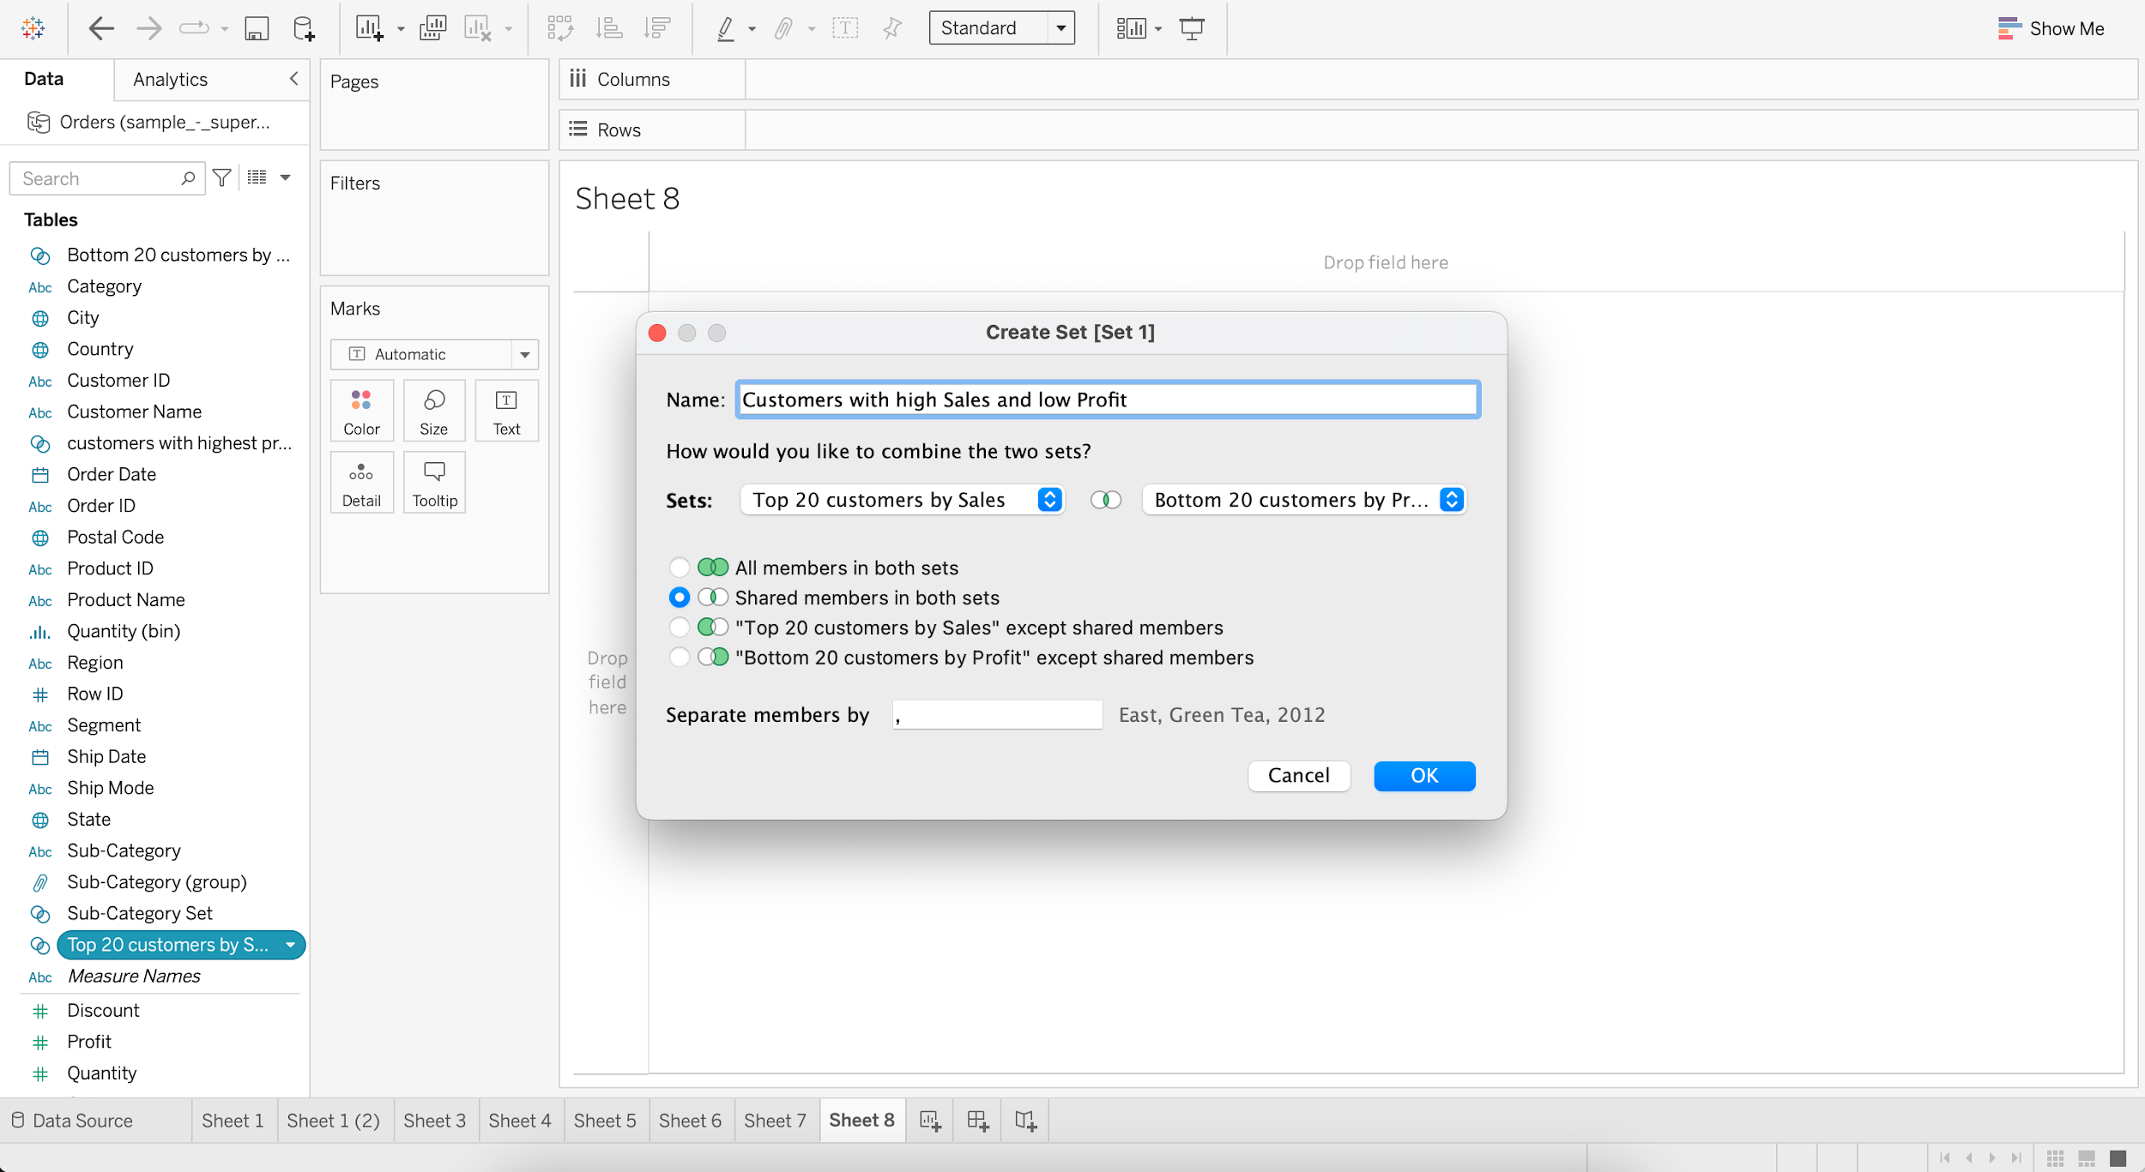

* + Drag Customer Name to Rows
  + Add Sales & Profit as Measure Values

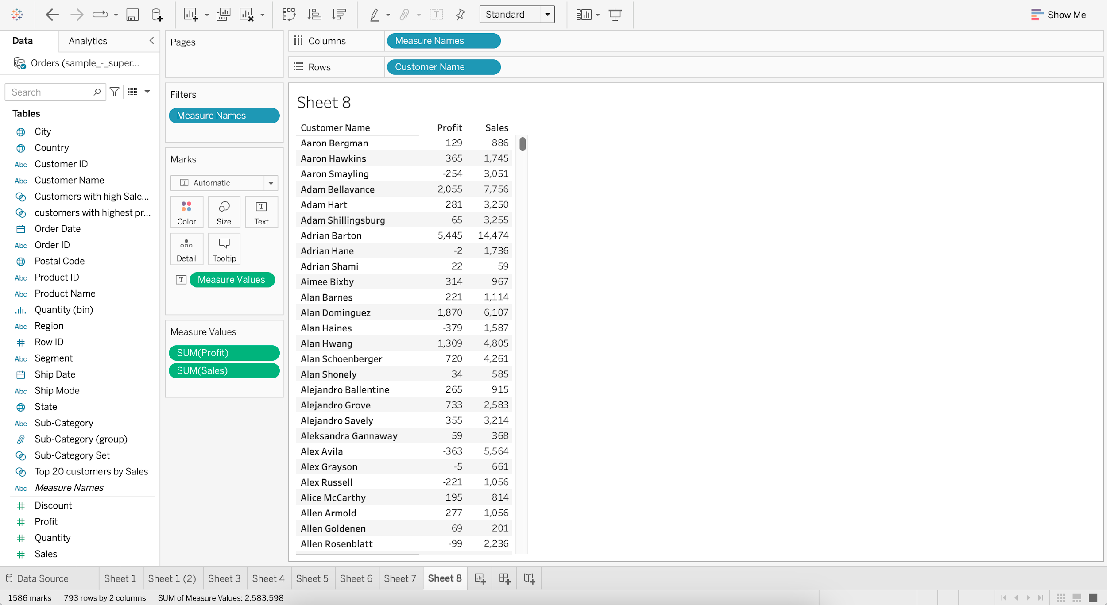

* + Put “Customers with high Sales and low Profit” into Filter

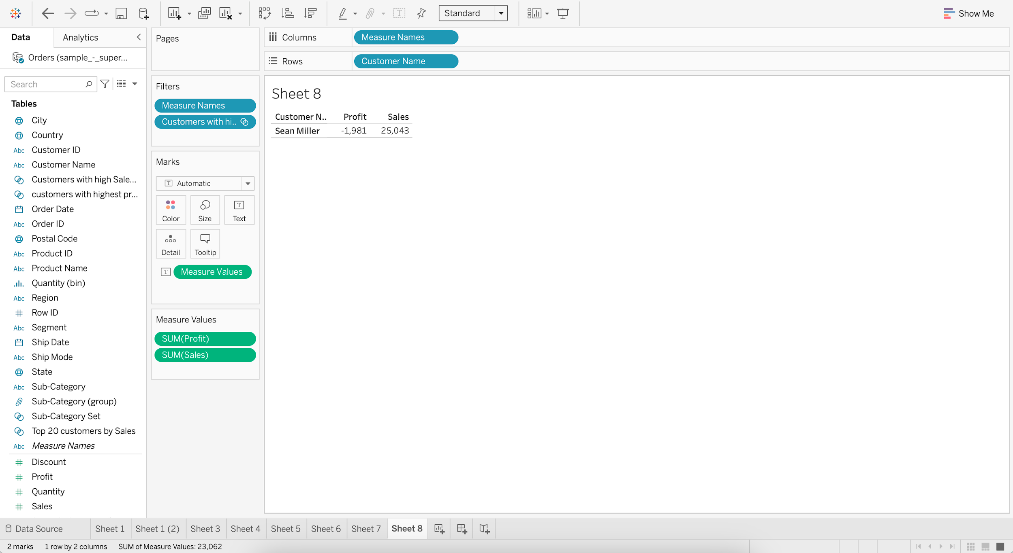

**Groups vs Sets**

| Group | Set |
| --- | --- |
| Static (must be manually changed) | (Can be) Dynamic |
| No limit to number of groups | Binary (In/Out) |
| Can be created on both Dimensions and Measures | Can be created only on Dimension |

### **Parameter**

* It is like a workbook variable that is used to replace constant value in a filter, calculation or reference lines.
* They are user generated values that are not necessarily attached to the dataset.

#### **Business problem 8 :**

* Allow users to filter out top N subcategories of products by average discount.
  + Create a Parameter as “Filter top N products”

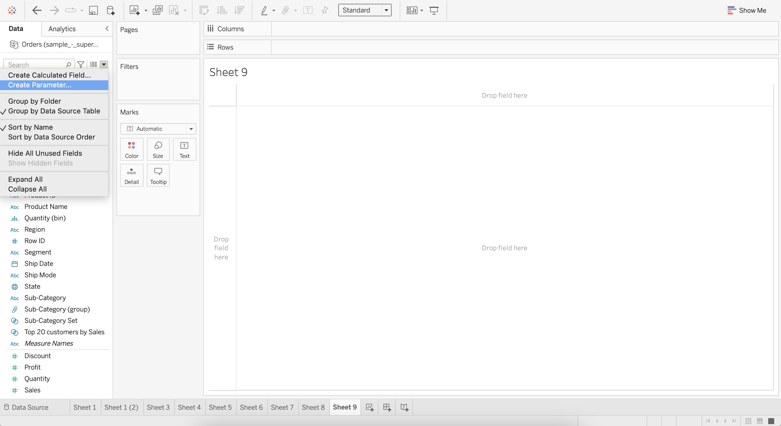

* + Set :
    - Data type as Integer
    - Current value as 1
    - Allowed values as Range
    - Minimum value as 1
    - Maximum value as 10
    - Step size as 1

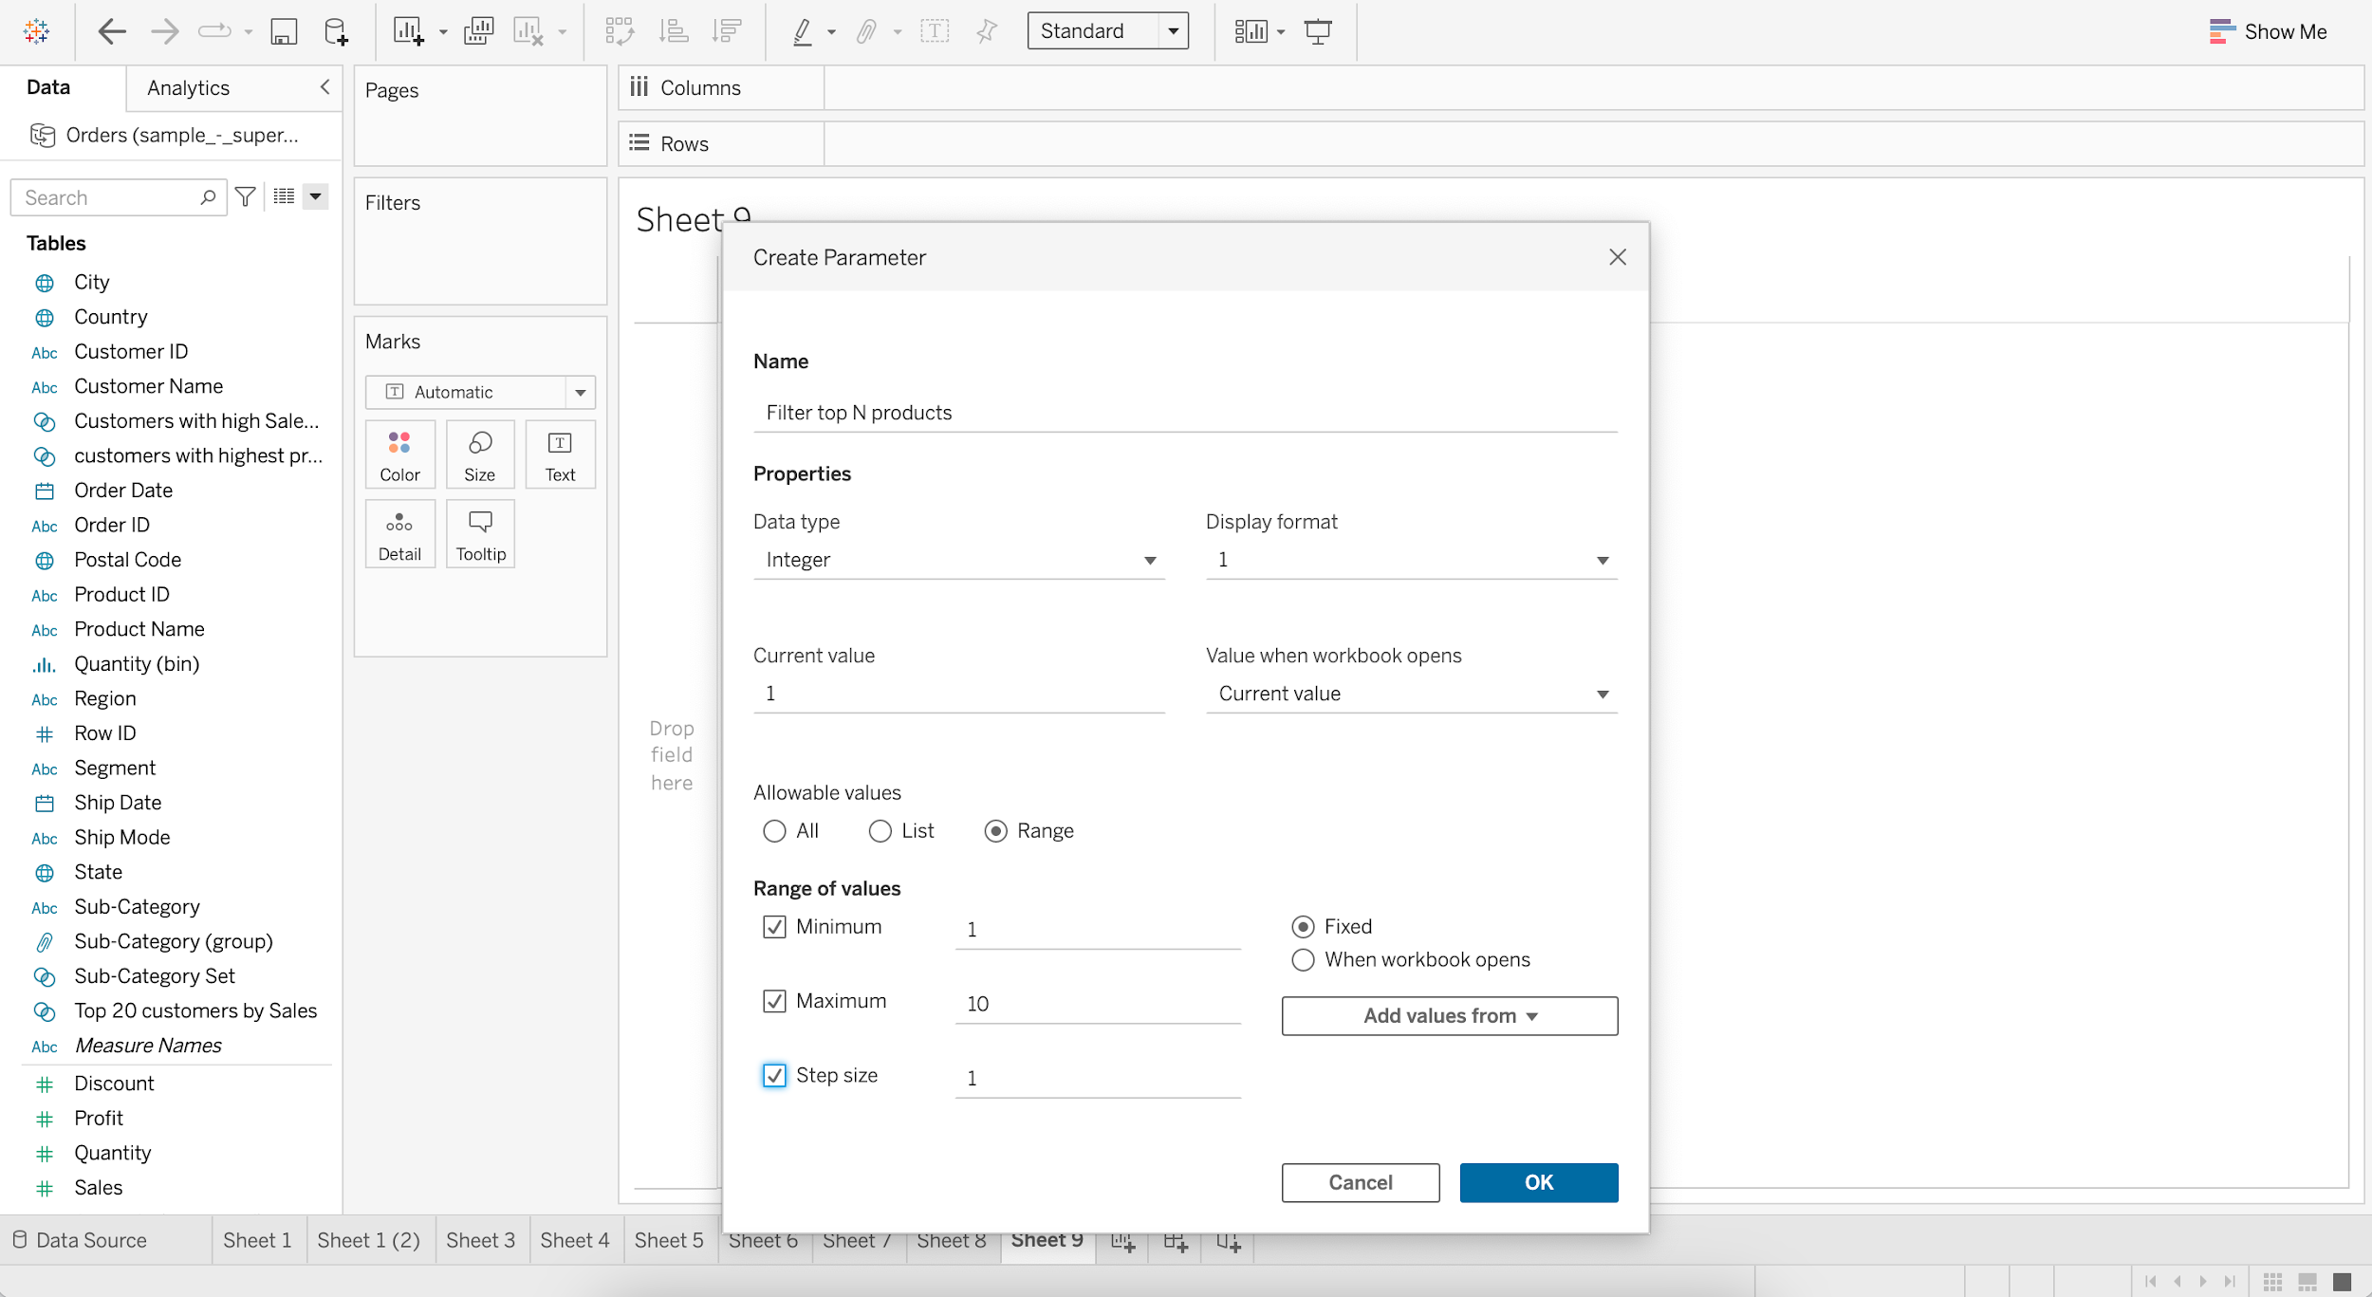

* + Display average discount for each subcategory.
    - Drag Sub-Category to Columns
    - Drag Discount to Rows
    - Change aggregation of Discount from Sum to Average

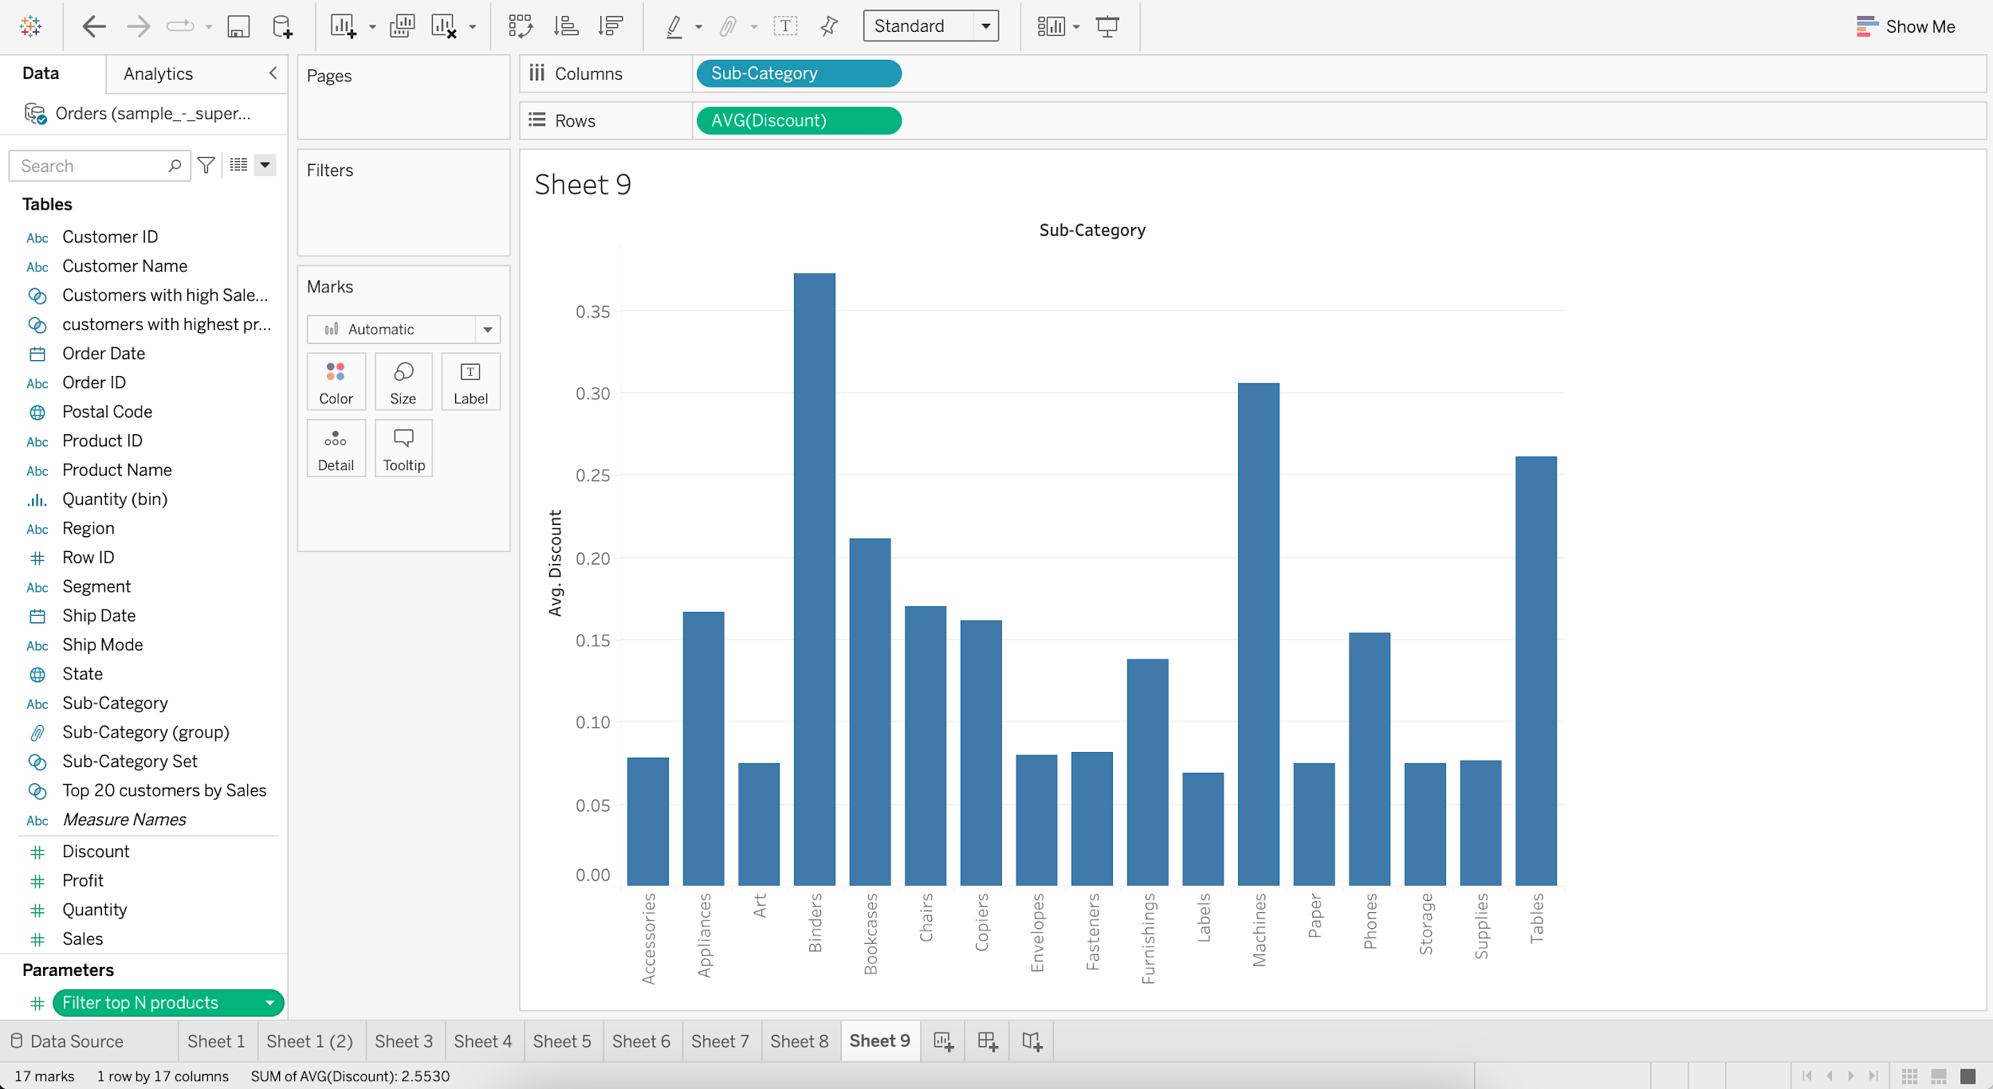

* + Go to “Filter top N products” and Show Parameter

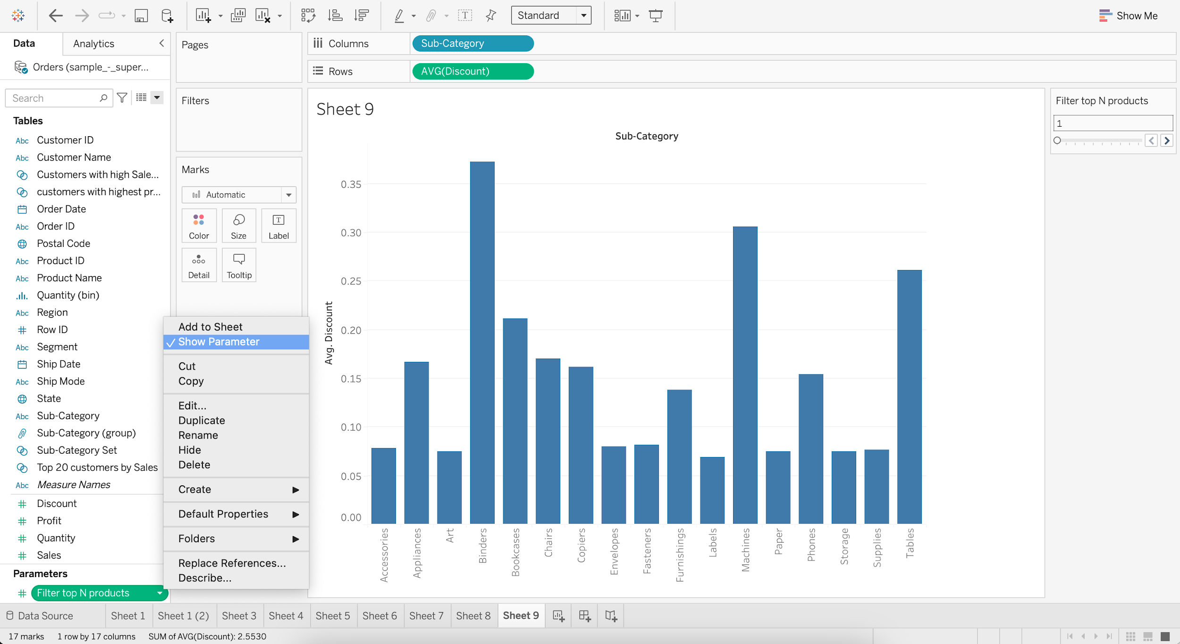

* + Put Sub-Category into Filter
  + Go to Top and Select Filter top N products by Average of Discount

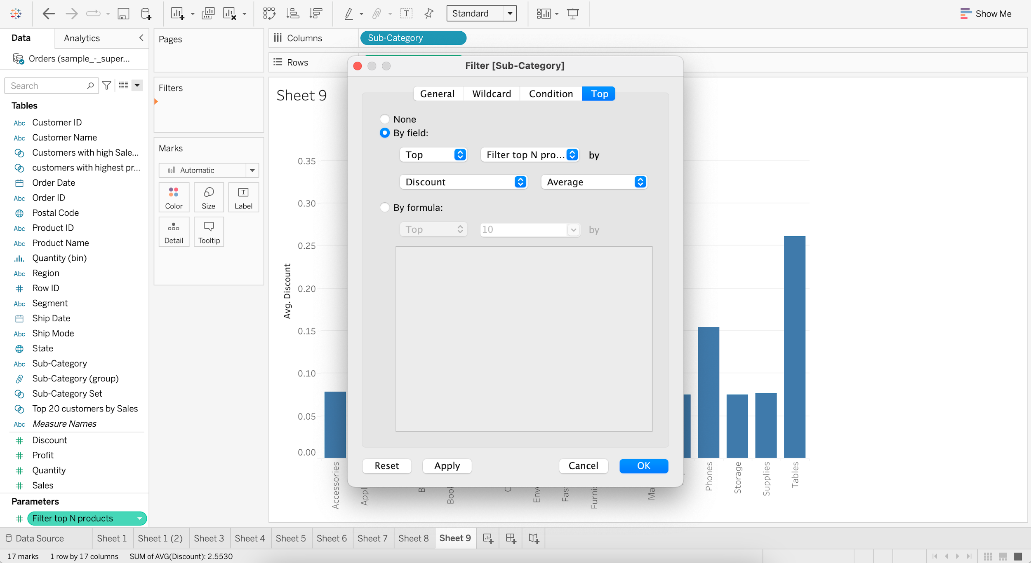

* + Increase value of “Filter top N products” to 5

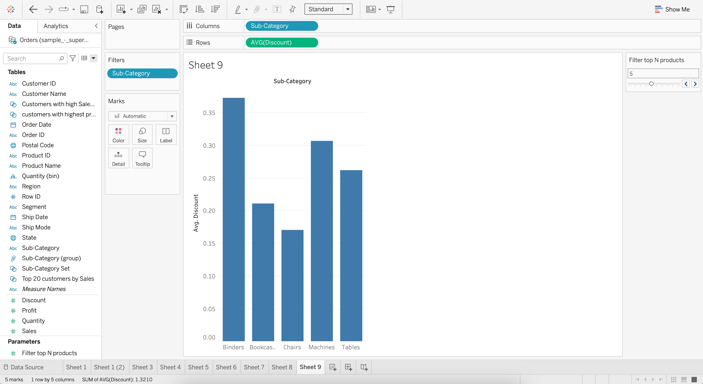

#### **Control Set with Parameter**

#### **Business problem 9 :**

* Have a parameter where the user can choose top N product subcategories by sales.
  + Create a null Set of Sub-Category
  + Go to Top and Select Top 10 by Sum of Sales

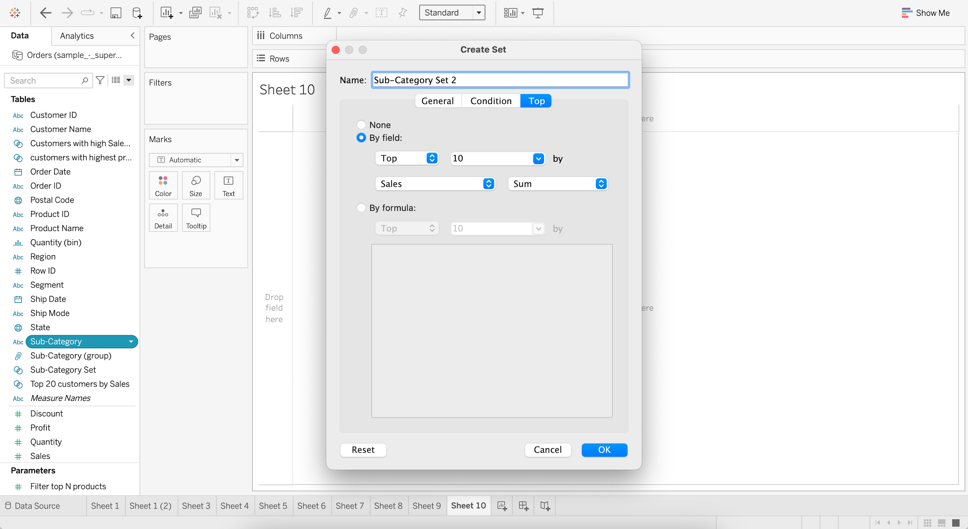

* + Create a Parameter as “Sub-Category Selector”
  + Set :
    - Data type as Integer
    - Current value as 1
    - Allowed values as Range
    - Minimum value as 1
    - Maximum value as 10
    - Step size as 1

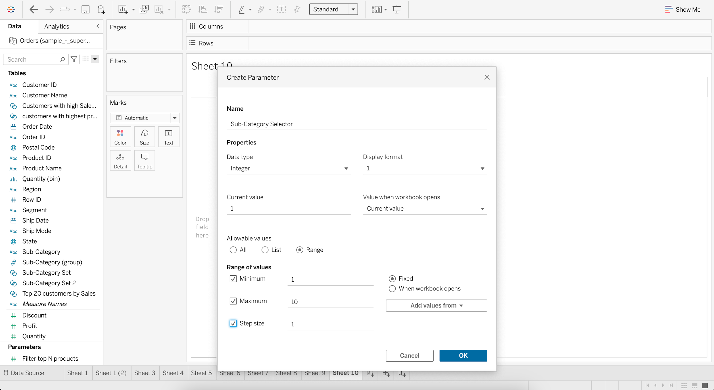

* + Edit Sub-Category Set 2
  + Go to Top and Select Sub-Category Selector

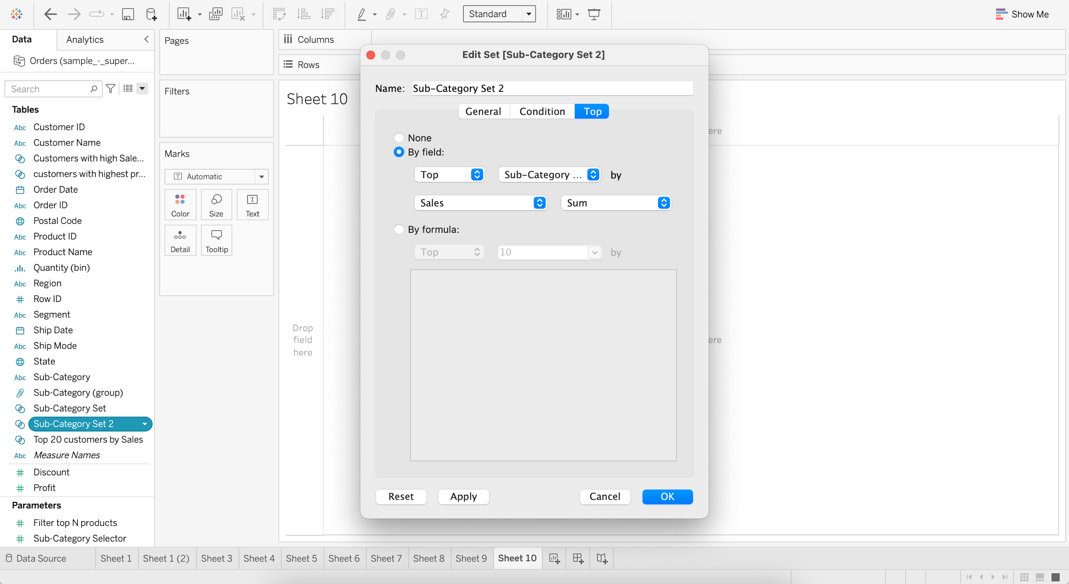

* + Drag Sub-Category to Rows
  + Drag Sales to Columns
  + Add Sub-Category Set 2 to Color

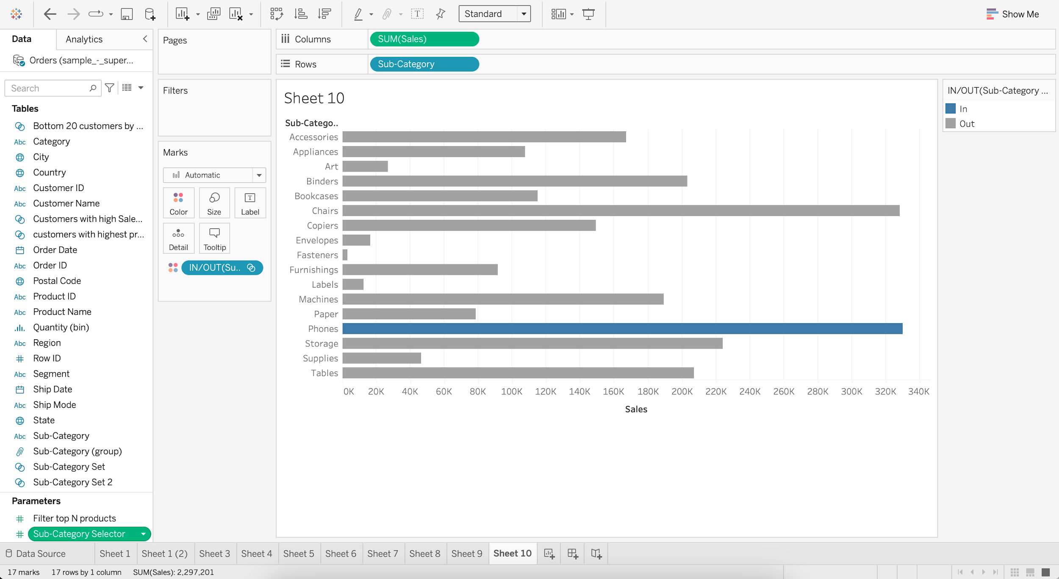

* + Go to “Sub-Category Selector” and Show Parameter
  + Increase value of “Sub-Category Selector” to 5

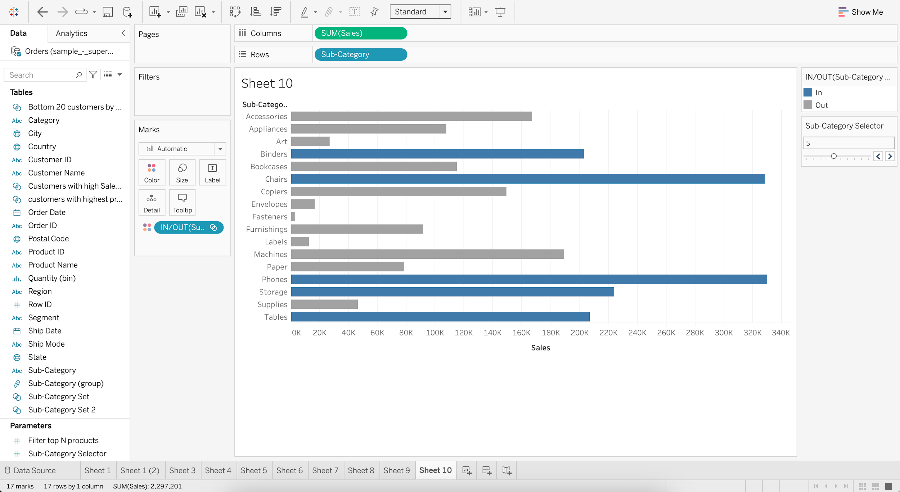

**Post-read:** [Hierarchy & Sorting](https://docs.google.com/document/d/1YOCqiDlb7FEzCx7qGsMzKd7QZNxUeTOfnBggszAzbLI/edit?usp=sharing)